JUDUL ARTIKEL (TITLE)
Penulis Satu (author 1)¹, Penulis Dua (author 2)^{1*},
Penulis Tiga (Last author)²
¹Dept. name of organization (of Affiliation), Name of organization (of Affiliation), City, Country
²Dept. name of organization (of Affiliation), Name of organization (of Affiliation), City, Country
*Corresponding author: single corresponding author email address
(Received: Day Month Year; Accepted: Day Month Year; Published on-line: Day Month Year)
ABSTRAK: Use the styles provided in this document to write your paper. You will find style name between brackets at the end of character or paragraph. (Abstract).
KEY WORDS: Font, Style, and Formatting. (Normal + title case). [Maximum five]
- PENDAHULUAN (HEADING 1)
In an attempt to make formatting easy, you can use the style menu just under the standard menu. Every button has a name similar to style name in brackets after each paragraph. (Normal).
- METODE PENELITIAN/PENGABDIAN (HEADING 1)
Leave spaces inside the text for figures and tables (keep figure caption in its space). Avoid using tab or enter buttons whenever possible. (Normal).

2.1. Illustrations (Heading 2)
Tables and figure should be placed within the text.

Figures, Tables, and Graphs (Heading 3)
To refer to a figure or a table in the text write; refer to Fig. 1 (for example). Figure caption should be written outside the figure or the table (not attached to the figure). Figures numbering should be absolute (not according to section numbers), for example: Fig. 1, Fig. 2, Fig. 3…. etc. (Normal).
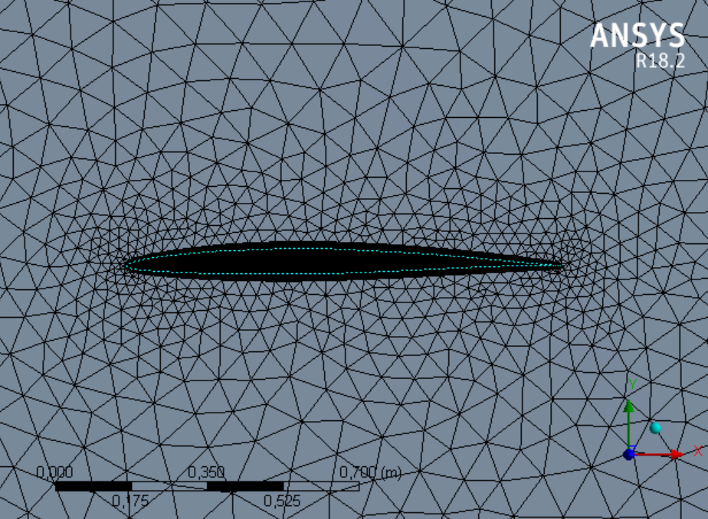
Gambar. 1. Return loss and resonant of the antenna for different types of MEMS bridge materials when the switches are ON.
Figures and table size should be as suitable as to fit in two-column page according to our journal format (see enclosed sample). Leave an empty space in the place of the figure using figure space style button. Put table title before the table and use table title style for it For example (Normal).
Tabe1 1: Example system technical data (table title)
Station | System Type | Length [m] |  | Diameter [m] | Mass [kg]
1 | ABC-9X | 2.951 |  | 0.123 | 66.00
2 | ABC-10Y | 4.466 |  | 0.145 | 144.88
3 | ABC-100Z | 3.011 |  | 0.167 | 155.99

Equations (Heading 3)
Write Equations and symbols using Microsoft equation editor or Mathtype. Equation numbering should be absolute as we did with figures. In addition, write refer to Eq. (1) if you want to refer to equation number 1 and write refer to Eq. (2) if you want to refer to equation number 2 and so on. Use only one Tab space between equation and its number.
If you want to refer to a paper or a book, write the number of the paper or the book that is corresponding to it in the Reference section. Use the style provided (refer), for example; write [1] wherever you want to refer to article number 1. Start with article number one then number two and so on. It is important also to arrange the references in the references section according to their appearance order in the text.
$rate=W_{q}k_{f}(\frac{a_{MTBE}}{K_{eq}{a_{MeOH}}^{2}})$ (1)
- KESIMPULAN (HEADING 1)
How to use this document?
• Press Ctrl+A to select all text then delete.
• Start writing your paper then select the appropriate style for each paragraph from style menu or make a copy of the whole paper text and paste it here, then select the appropriate style for each paragraph. (It is recommended to remove any special formatting before using paste)
• Save your paper with different name not to overwrite the original document.
• Use only simple format for your paper.

UCAPAN TERIMA KASIH (ACKNOW)
The acknowledgements come at the end of an article after the conclusions and before the references

DAFTAR RUJUKAN
- Wang QH, Kalantar-Zadeh K, Kis A, Coleman JN, Strano MS. (2012) Electronics and optoelectronics of two-dimensional transition metal dichalcogenides. Nature Nanotechnology, 7(11):699-712.
- Passler R. (2001) Dispersion-related assessments of temperature dependences for the fundamental band gap of hexagonal GaN. J. Applied Physics, 90(8):3956-3964.
- Walukiewicz W, Li SX, Wu J, Yu KM, Ager JW, Haller EE, Lu H, Schaff WJ. (2004) Optical properties and electronic structure of InN and In-rich group III-nitride alloys. J. Crystal Growth, 269:119–127.
- Cui K, Fathololoumi S, Kibria MG, Botton GA, Mi Z. (2012) Molecular beam epitaxial growth and characterization of catalyst-free InN/InxGa1-xN core/shell nanowire heterostructures on Si (111) substrates, Nanotechnology, 23(8):085205.
- Incropera FP, DeWitt DP, Bergman TL, Lavine AS. (2011) Introduction to Heat Transfer, 7th Ed.
- Bejan A, Kraus A. (2003) Heat Transfer Handbook, USA.
- The Contiki operating system. Available: http://www.contiki-os.org/index.html.

